Vending Machine User Manual

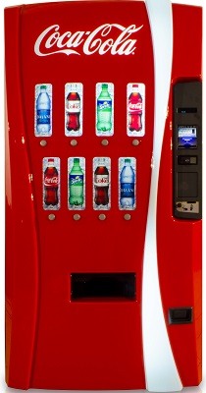

Page Index:

System Requirement………………………..………………………..………………………..2

Installation Guide………………………..………………………..…………………………...

User Interface………………………..………………………..………………………….........

Pressing Amount to Buy………………………..………………………..…………………….3

How Much Money Owed………………………..………………………..……………………

Entering Amount of Money……………………………………………………………………

Refilling Vending Machine…………………………………………………………………….4

Credit…………………………………………………………………………………………...

**System Requirement:**

1. Any IOS devices
2. Window 7-10
3. Linux
4. IDE (Eclipse, Net Bean, etc…)

**Installation Guide:**

1. Download and install the latest version of Java.
2. Run and extract the components of the Java Jar file.
3. Install a suitable IDE.
4. Head to Github and download the Vending Machine project package folder.
5. After installing all the necessary files, open with suitable IDE.

**User Interface:**

1. Pressing amount to buy
   1. By clicking on every soda that are listed (Coke, Diet Coke, Pepsi, etc…), the quantity will decrease by one.
   2. Each soda has a limit of 100 cans. If pressed beyond the 100 cans limit, a message will appear that will say, “Sorry, we’re out of stock! Try again tomorrow.

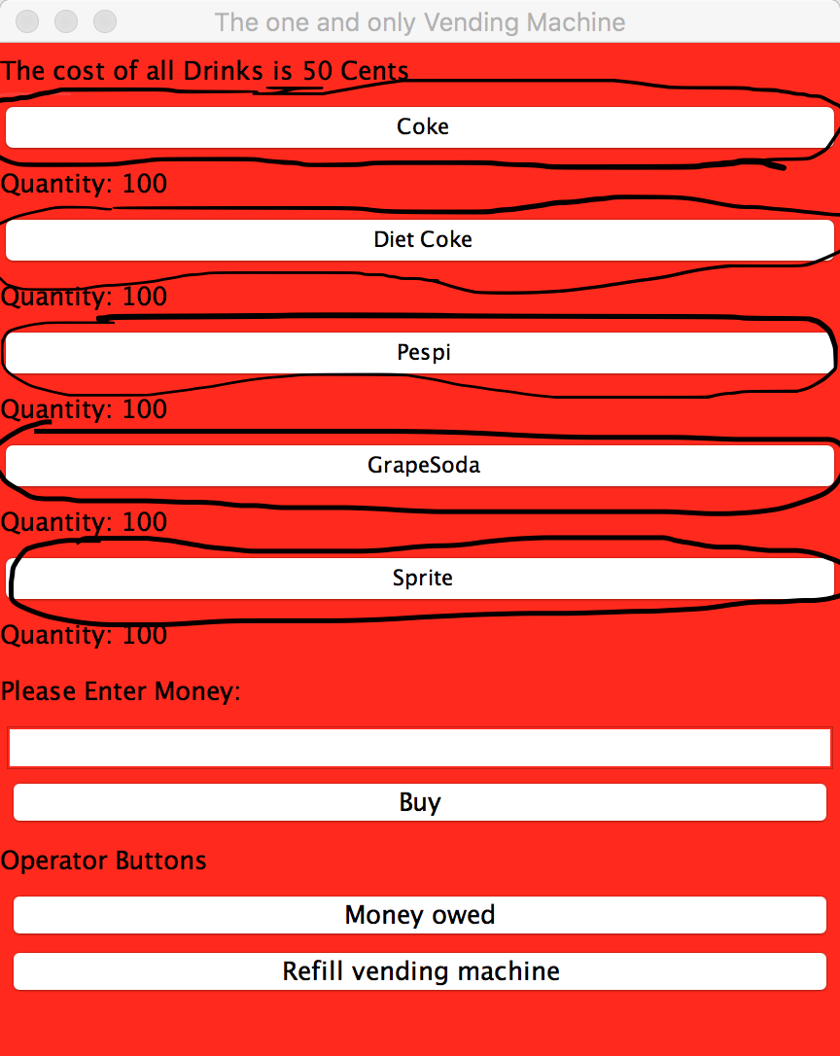

1. How much money owed
   1. After selecting the sodas of choice, pressing on the “Money owed” button under “Operator Buttons” will tell the amount owed.

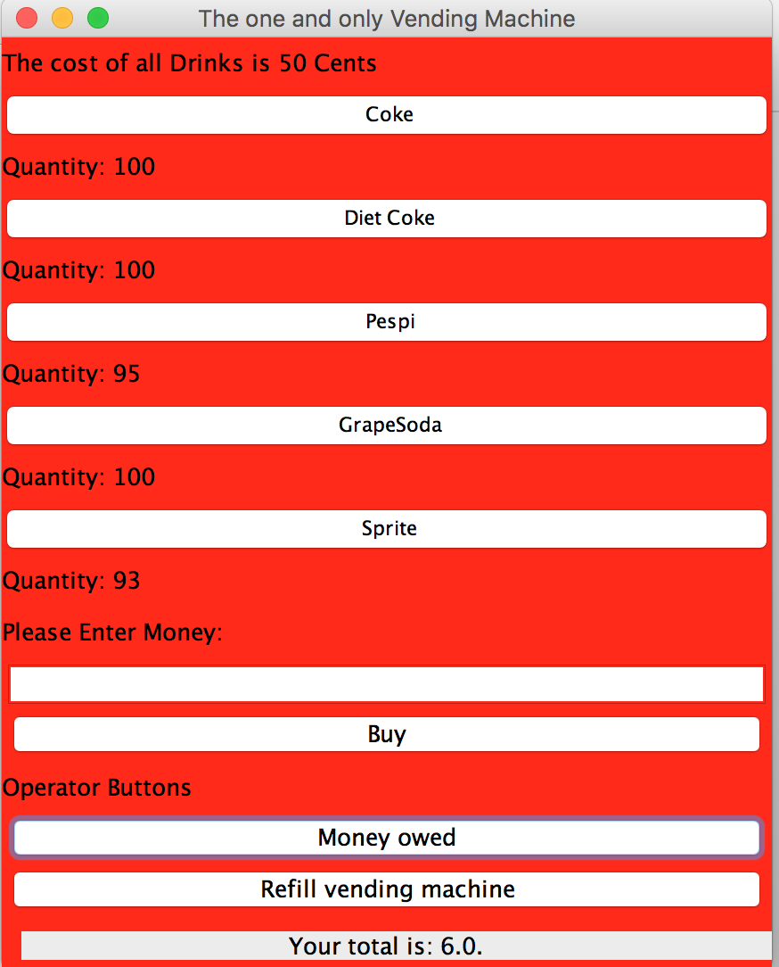

1. Entering Amount of money
   1. Once you figured out how much you owe, under the “Please Enter Money,” the user will type in the amount they would like to put in.
   2. If the user puts in less than they owe, a message will say, “Sorry, not enough money! Try entering another amount of money.”
   3. If the user puts in too much money, a message will say, “Sorry, that’s too much! Try entering another amount of money.”
   4. The amount of money returned will be in coins after successfully buying.

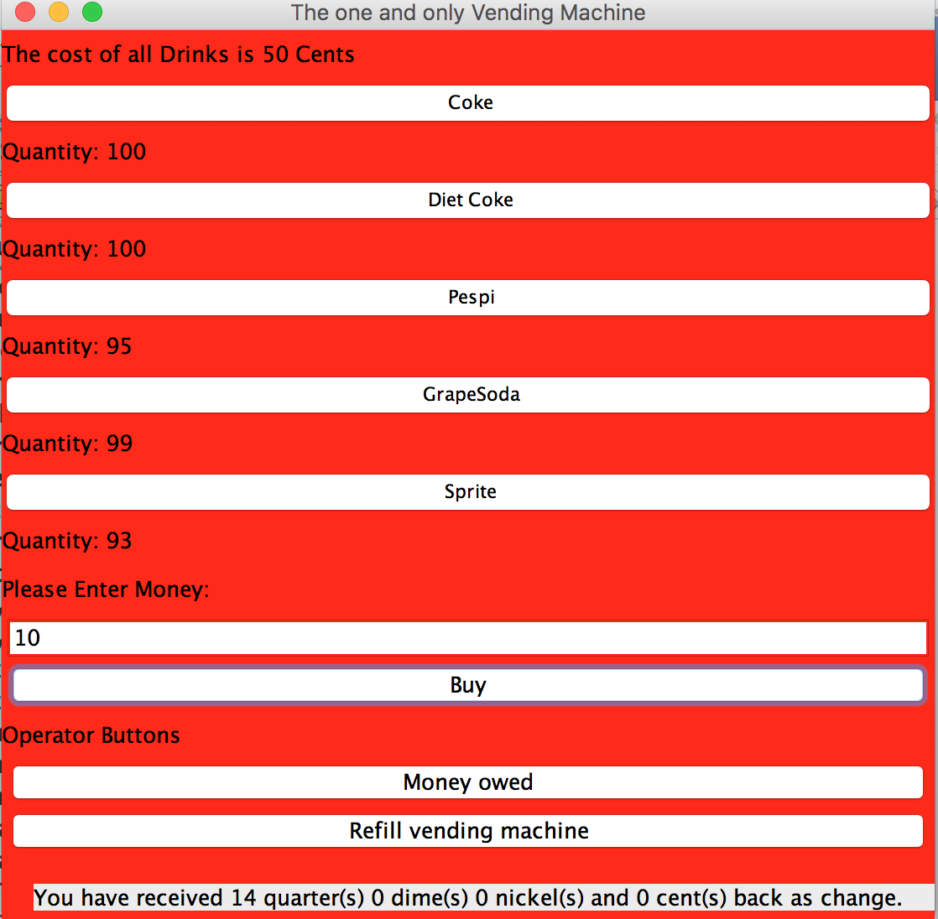

1. Refilling Vending Machine
   1. If there is no more soda that the user desire, the user should press on the “Refill vending machine” button, and the vending machine shall be completely restocked.

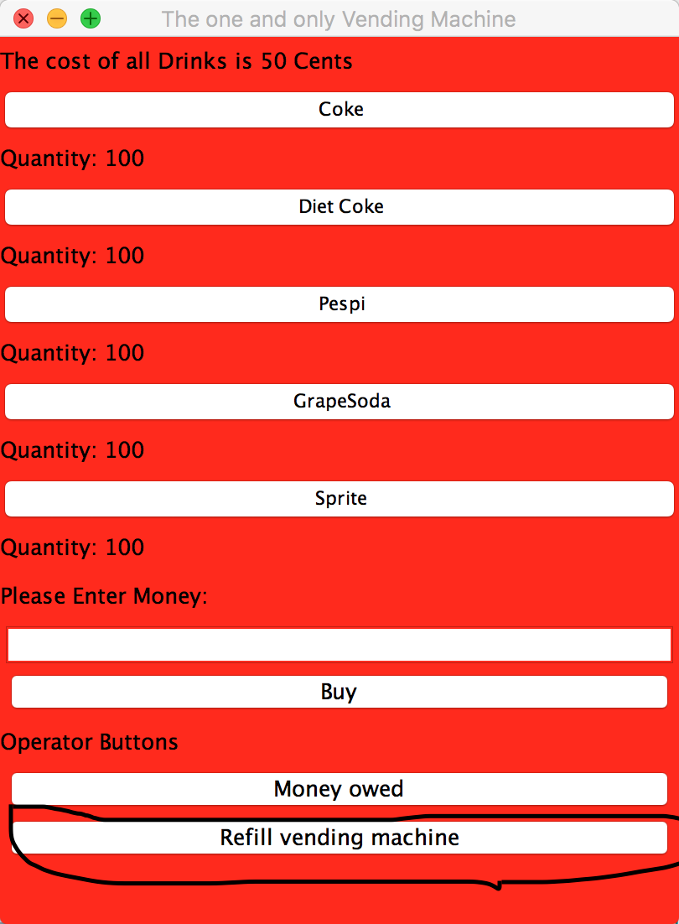

**Credit:**

Developer: Kristian Sandoval

Team Leader/Developer: Dylan Monroe

Drew Melton

Omar Ahmed

Documenter/ QA: Timothy Nguyen

Megan Kennemore